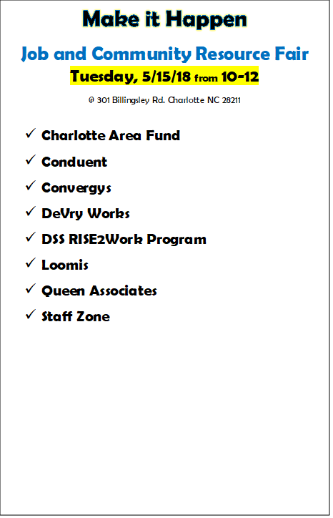

Up to date **resumes** are helpful. If you need to update or print yours, stop by the DSS Career Services Centers

@301 Billingsley Rd, open Monday-Friday from 8:30-3

@3205 Freedom Dr, open Monday-Friday from 8-5

**Happy New Year!**

Make it Happen Job and Resource Fair

Tuesday, 1/22/19 from 10-12

@ 301 Billingsley Rd. Charlotte NC 28211

Employer and Resource Providers that have signed up to attend:

Charlotte Mecklenburg Schools

G4S Secure Solutions

Liberty

Labor Finders

Occupancy Heroes

Trace Staffing

Walden Security

Mecklenburg County Sherriff’s Office

Novant

Vocational Rehabilitation (hiring and resources)

Urban League

Charlotte Mecklenburg Library Job Help Centers

RISE2Work

University of Phoenix

YMCA

OMITT Trade School

Charlotte Area Fund